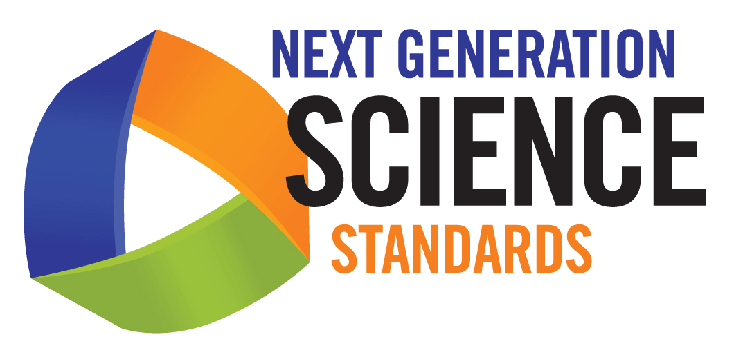
Disciplinary Core Ideas
Physical Sciences

PS1—MATTER AND ITS INTERACTIONS
How can one explain the structure, properties, and interactions of matter?
PS1.A: Structures and Properties of Matter: How do particles combine to form the variety of matter one observes?
PS1.B: CHEMICAL REACTIONS: How do substances combine or change (react) to make new substances? How does one characterize and explain these reactions and make predictions about them?
PS1.C: NUCLEAR PROCESSES: What forces hold nuclei together and mediate nuclear processes?

PS2—Motion and Stability: Forces and Interactions
How can one explain and predict interactions between objects and within systems of objects?
PS2.A: Forces and Motion How can one predict an object’s continued motion, changes in motion, or stability?
PS2.B: TYPES OF INTERACTIONS: What underlying forces explain the variety of interactions observed?
PS2.C: STABILITY AND INSTABILITY IN PHYSICAL SYSTEMS: Why are some physical systems more stable than others?

PS3—Energy
How is energy transferred and conserved?
PS3.A: DEFINITIONS OF ENERGY: What is energy?
PS3.B: CONSERVATION OF ENERGY AND ENERGY TRANSFER: What is meant by conservation of energy? How is energy transferred between objects or systems?
PS3.C: RELATIONSHIP BETWEEN ENERGY AND FORCES: How are forces related to energy?
PS3.D: ENERGY IN CHEMICAL PROCESSES AND EVERYDAY LIFE: How do food and fuel provide energy? If energy is conserved, why do people say it is produced or used?

PS4—Waves and Their Applications in Technologies for Information Transfer
How are waves used to transfer energy and information?
PS4.A: WAVE PROPERTIES: What are the characteristic properties and behaviors of waves?
PS4.B: ELECTROMAGNETIC RADIATION: What is light? How can one explain the varied effects that involve light? What other forms of electromagnetic radiation are there?
PS4.C: INFORMATION TECHNOLOGIES AND INSTRUMENTATION: How are instruments that transmit and detect waves used to extend human senses?

