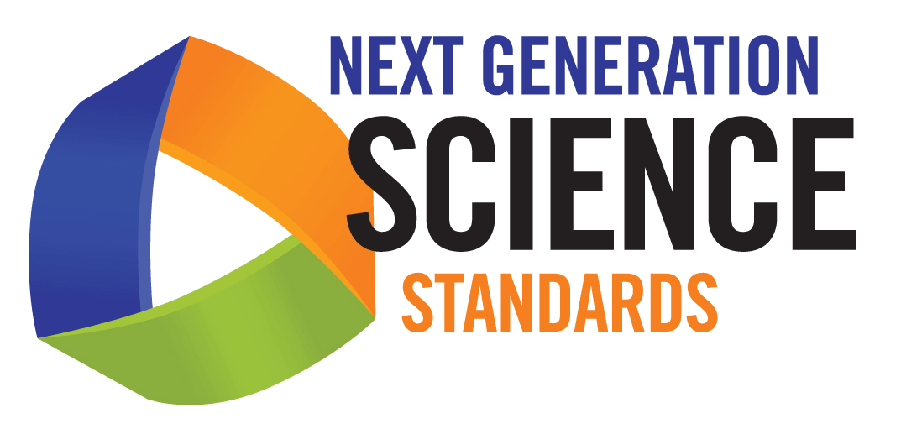

Disciplinary Core Ideas

Physical Sciences
PS1—MATTER AND ITS INTERACTIONS
How can one explain the structure, properties, and interactions of matter?
PS2—Motion and Stability: Forces and Interactions
How can one explain and predict interactions between objects and within systems of objects?
PS3—Energy
How is energy transferred and conserved?
PS4—Waves and Their Applications in Technologies for Information Transfer
How are waves used to transfer energy and information?

Life Sciences
LS1—From Molecules to Organisms: Structures and Processes
How do organisms live, grow, respond to their environment, and reproduce?
LS2—Ecosystems: Interactions, Energy, and Dynamics
How and why do organisms interact with their environment and what are the effects of these interactions?
LS3—Heredity: Inheritance and Variation of Traits
How are characteristics of one generation passed to the next? How can individuals of the same species and even siblings have different characteristics?
LS4—Biological Evolution: Unity and Diversity
How can there be so many similarities among organisms yet so many different kinds of plants, animals, and microorganisms? How does biodiversity affect humans?

Earth and Space Sciences
ESS1— Earth’s Place in the Universe
What is the universe, and what is Earth’s place in it?
ESS2—Earth’s Systems
How and why is Earth constantly changing?
ESS3—Earth and Human Activity
How do Earth’s surface processes and human activities affect each other?

