**Awareness Resources for the Next Generation Science Standards (NGSS)**

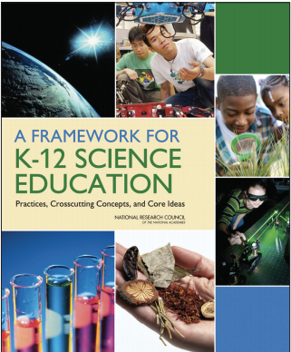

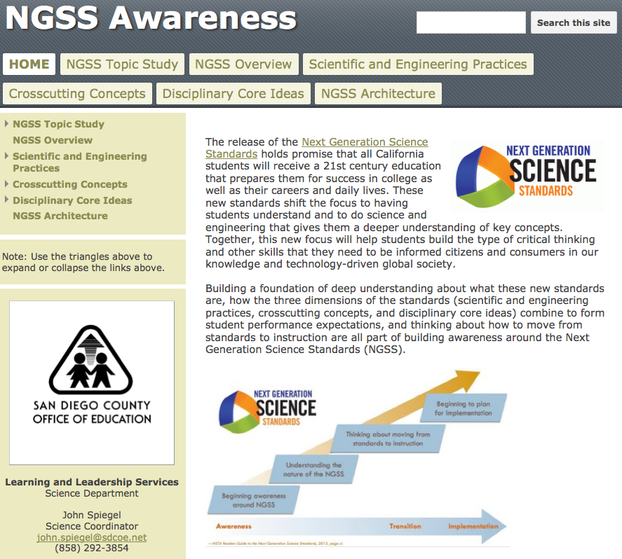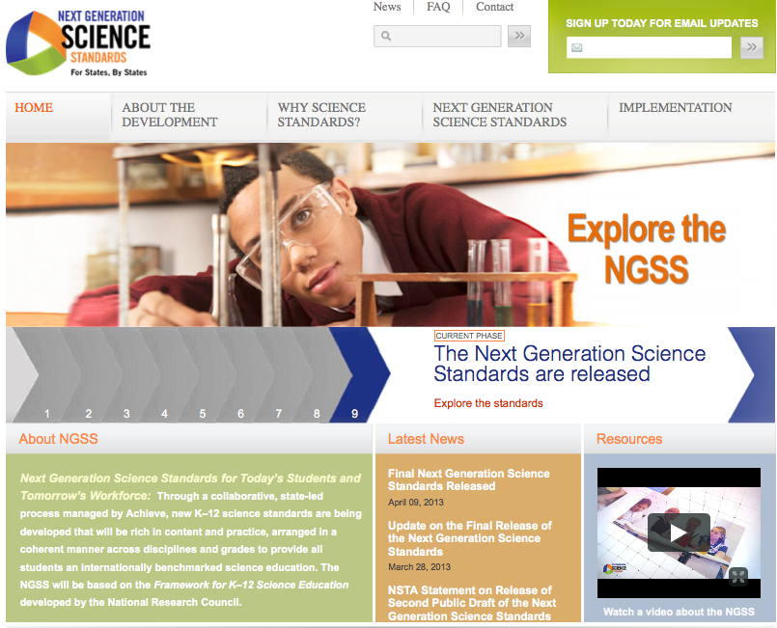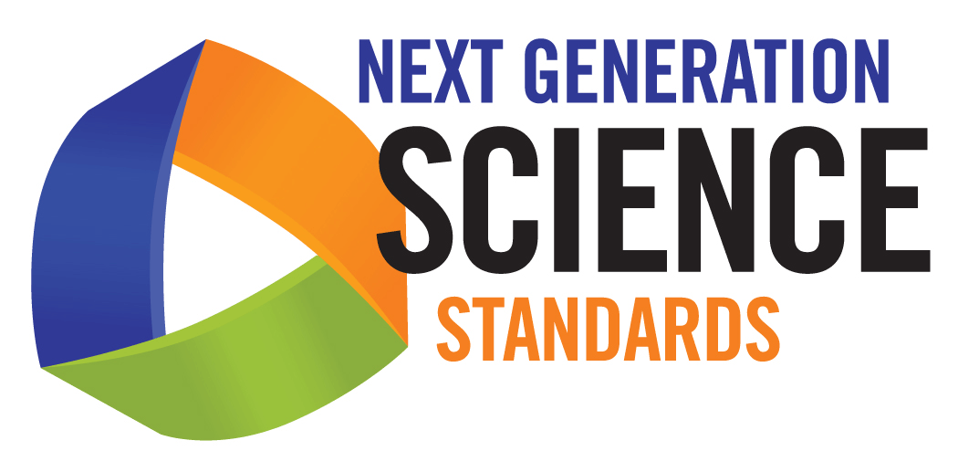

**Framework for K-12 Science Education**

www.nap.edu/catalog.php?record_id=13165

**NGSS Awareness Website**

https://sites.google.com/site/ngsssd

**NextGenScience Website**

www.nextgenscience.org/next-generation-science-standards

John Spiegel

Science Coordinator

john.spiegel@sdcoe.net

858-292-3854